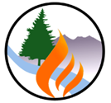 | Flagstaff Watershed Protection Project  From Inception to Voter-Approval:  How Did We Get Here?  August 2013

Overview: The Flagstaff Watershed Protection Project (FWPP) is the culmination of almost two decades of progressive, comprehensive wildland fire management, resulting in a gradual and profound paradigm shift within the community. As a result of an aggressive Prevention, Preparedness, Hazard Mitigation, Response, and Recovery effort, the community has moved from a mid-1990s view that “all trees are good and all fires are bad” to one not only embracing, but demanding a multi-faceted program to reduce the risk of catastrophic wildfire, provide for forest protection and sustainability, and ensure community well-being.

Community outreach and engagement in on-going forest treatments played a major role in this change. Continuous selective tree removal, debris disposal, and prescribed fire, both within and outside the City, conducted by the Fire Department (FFD), AZ State Forestry (ASF) and AZ State Land Department (ASLD), and the U.S. Forest Service (USFS), along with other partners, allowed citizens to become comfortable with the process and results.

During the past decade, success in controlling emerging fires as they moved into these treated areas has dramatically demonstrated the value of this work and reinforced the need for large-scale proactive action and collaborative partnerships. The community grew to understand that the affects of severe wildfire, including post-fire flooding would have immediate and lasting effects to the community, affecting tourism, home and property values, scenic quality, water supply, and other values. | 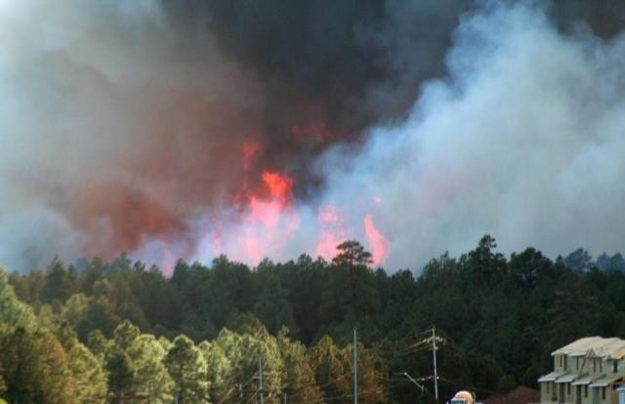  The 2006 Woody Fire resulted in evacuations,  but was stopped with no structure loss when it  burned into a previously treated area

In November 2012, voters authorized a $10 million municipal bond with a 73.6% approval rate to fund treatments in the Rio de Flag and Lake Mary watersheds. Both watersheds are located largely outside of the City boundary on the Coconino National Forest, but the impacts stemming from a severe fire in these areas would directly impact the City.

The election victory demonstrated community understanding of the vulnerability of these two watersheds and a commitment to act rather than wait for the inevitable fire. As a result, the City, ASF, ASLD, and the USFS, along with other parties including Coconino County, Greater Flagstaff Forests Partnership (GFFP), Northern Arizona University Ecological Restoration Institute (ERI), and others have embarked upon a unique one-of-a-kind partnership to address concerns and ensure a safe, bright, and green future.

Actions and Key Milestones:
- 1996 - The Hochderffer and Horseshoe fires burned 25,000 acres outside of town. At the same time, three fires each over 100 acres in size burned within Flagstaff City limits, shocking the community, prompting public outcry, and initiating discussions to “fix the problem.”
- 1997 - GFFP is founded and the City’s Wildland Fire Management (WFM) division is created. Primary GFFP partners include: ERI (science/academic), USFS (primary land management agency in area), Grand Canyon Trust (environmental nonprofit), and the City (political).
- 1998 - GFFP initiates the collaborative effort to educate the public, plan, and initiate treatments of at-risk areas. In cooperation with the USFS, State, and the City’s WFM Division, the effort will eventually lead, over the next 15 years, to over 70,000 acres of completed treatment.
- 1999 - The City initiates the requirement that all developments complete site-specific fuel reduction efforts before any construction can begin: the effort is widely accepted.
- 2000 - The Cerro Grande fire burns through Los Alamos, NM, prompting Secretary of the Interior Bruce Babbitt to call for wide-scale implementation of “the Flagstaff model.”
- 2001 - The Arizona Governor visits Flagstaff to participate in a neighborhood Firewise program.
- 2002 - The Rodeo-Chediski fire burns over 462,000 acres in eastern Arizona, at that time the largest fire in Arizona history. City Council members spend 36 hours at the fire, observing both the Incident Management Team and the impacts of such a fire on the local communities.
- 2003 – Bark beetles explode in the Flagstaff area, killing thousands of trees in the next two years.
- 2004 - The Flagstaff Mayor participates in a prescribed broadcast burn.
- 2005 - The Greater Flagstaff Area Community Wildfire Protection Plan (CWPP) is adopted.
- 2006 - The Woody Fire ignites in mid-June, but is successfully suppressed the same afternoon as it burned into previously treated areas.
- 2007 – FFD is awarded the national Firewise Leadership award.
- 2008 - After 18 months of development work and community outreach, the City adopts the Flagstaff Wildland Urban Interface Code.
- 2009 – Nominal Vegetation Management permit fees are implemented.
- 2010 - In June, the Hardy Fire erupts in east Flagstaff, threatening multiple businesses and neighborhoods, but is contained when it burns into an area treated 2-3 years earlier.
The next day, the Schultz Fire explodes east of town, eventually burning over 15,000 acres. In July, heavy monsoonal moisture results in substantial debris flows, severe erosion, and widespread flooding in county areas outside the city. Suppression costs approached $12 million, but in the three years since, continuing flooding and recovery efforts will exceed $130 million. | 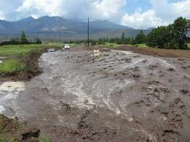  The lessons of the Schultz fire and flooding  were not lost on Flagstaff residents
- 2011 - The 538,000 acre Wallow Fire surpasses the Rodeo-Chediski as the largest wildfire in Arizona history. Communities, lives, and local economies are impacted, and ecological damage is widespread. WFM Staff and GFFP members attend a workshop in Santa Fe, NM to learn what that community has done to protect their watersheds: over the next several months, the two communities continue to discuss the Payment for Watershed Services (PWS) approach.
- 2012 - In March . . .
City Staff attend a ½ day workshop to learn about PWS and a decision is made to move the concept forward to Council. Staff immediately engage other key partners and begin to refine the issue and need. In July, Council approves inclusion of the FWPP on fall general election ballot as Question #405, the first time a PWS-type effort has ever been put to voter approval. Yes on 405, a citizen group, forms to support the measure. In November, after an intensive campaign, voters approved the measure. | 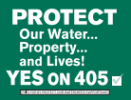  The City’s role was informational in-nature, while the Citizen group focused on advocacy

Conclusions/Next Steps: FWPP is an innovative approach. The continual and steady effort in the years preceding the election paved the way for overwhelming voter support. FWPP contrasts with traditional fuel reduction and forest restoration efforts by combining municipal bond investment and agency budgets, to fund planning, treatment, and monitoring efforts in areas that would otherwise go untreated.

