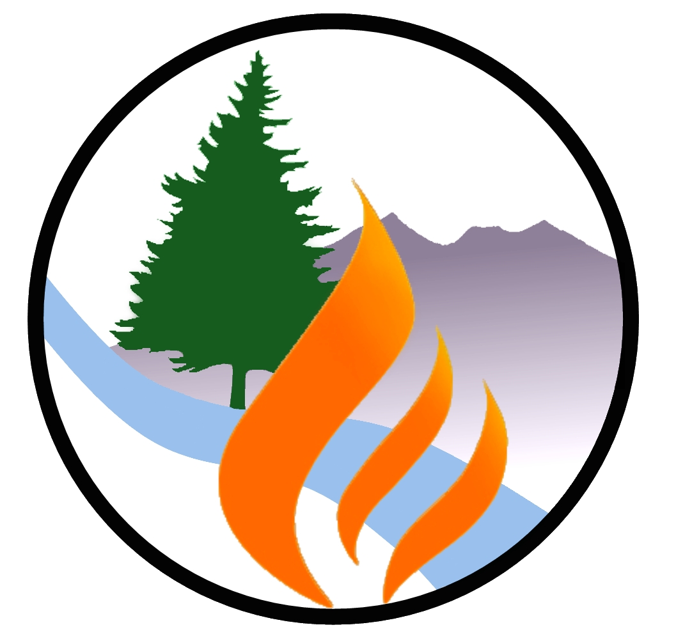 | FLAGSTAFF WATERSHED PROTECTION PROJECT  FINAL EQUESTRIAN PROJECT SURVEY  Dec 11, 2014

Mailed Oct 20th to residents living adjacent to the Project site (University Heights & Highlands, and Equestrian Estates neighborhoods): Of the 102 surveys mailed, we received 19 back (19% return rate).

1) What impact do you believe the work had on the wildfire threat to your neighborhood?
1 2 3 4 4.8 5
Made it worse No Difference Greatly reduced

2) Were you aware that the work was going to occur before it began:
84% Yes 16% No

3) How does the area appear to you now that cutting is over?
1 2 3 4 4.7 5
Worse The same Much better

4) Comments:
a) Nice Job! Fence at entrance an unexpected bonus – thanks!
b) The forest personnel were friendly and courteous: thank you for doing the work!
c) Still need to burn off the ground fuel: That aspect is now much worse. Not talking about just the debris piles.
d) A little disappointed with the # of large branches on the ground that didn’t make it to
the debris piles, but we are glad the work was done.
e) I appreciate the work that was done to make the neighborhood more safe from fire.
f) Thanks you! Glad the wood was used and not burned!
g) Appreciate the work that was done to make the neighborhood more safe from fire.
h) More light to the forest floor, more sky visible, park-like appearance – outstanding!
I) Job well done – thank you!
j) Healthier forest by removal of smaller trees create stronger growth for larger trees
and plant life and reduce fire threat: thanks!
k) I am thankful the logging was done: Great fence at entrance to Equestrian!
l) Thank you for making our neighborhood & Flagstaff more safe from wildfires. We
truly appreciate your efforts.
m) Thank you for your service!
n) Well done!
o) The wood cutters were fast!
p) Appreciate the fence.
q) Thrilled with the thinning: will look great soon. We’ve noticed more migratory bird
species not seen before, including a pair of orioles!

